ASSIGNMENT 13

- WAF to raise a number to a power

//WAF to raise a number to a power
#include<iostream.h>
#include<conio.h>
#include<stdio.h>
int power(int,int);
main()
{
clrscr();
int base,exp,res;
cout<<"Enter base ";
cin>>base;
cout<<"Enter exponent ";
cin>>exp;
res=power(base,exp);
cout<<"The result is "<<res;
getch();

}
power(int base,int exp)
{
int res=1;
for(int i=1;i<=exp;i++)
res=res*base;
return(res);
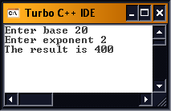
}
2) WAF to check if a number is odd or even
// WAF to check if a number is odd or even
#include<iostream.h>
#include<conio.h>
#include<stdio.h>
void oddoeven(int);
void main()
{
clrscr();
int num;
cout<<"Enter number ";
cin>>num;

oddoeven(num);
}
void oddoeven(int num)
{
if(num%2==0)
cout<<endl<<"It is Even";
else
cout<<endl<<"It is odd";
getch();
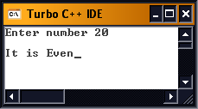
}
3) WAF to check if a person can vote
// WAF to check if a person can vote
#include<iostream.h>
#include<conio.h>
#include<stdio.h>
void checkvote(int,char);
void main()
{
clrscr();
int age;
char cship;
cout<<"Enter age ";
cin>>age;
cout<<"Enter citizenship ";
cin>>cship;
checkvote(age,cship);
}
void checkvote(int age, char cship)
{
if(age>=18 && cship=='i')
cout<<endl<<"You can VOTE";
else
cout<<endl<<"YOU cant VOTE";
getch();
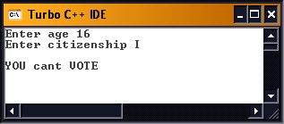
}
WAF to give area of a triangle,square and circle

//WAF to give area of a triangle,square and circle
#include<iostream.h>
#include<conio.h>
#include<stdio.h>

int area(int,int,int);
void main()
{
clrscr();
int choice;
float ar;
cout<<"1) Rectangle"<<endl<<"2) Circle"<<endl<<"3)Triangle"<<endl<<"choice ";
cin>>choice;
if(choice==1)
{
int len,br;
cout<<"Enter length ";
cin>>len;
cout<<"Enter breadth ";
cin>>br;
ar=area(len,br,choice);
cout<<"Area is "<<ar;
}
else if(choice==2)
{
float rad,pi=3.14;
cout<<"Enter radius ";
cin>>rad;
ar=area(rad,pi,choice);
cout<<"Area is "<<ar;
}
else if(choice==3)
{
int base,ht;
cout<<"Enter base ";
cin>>base;
cout<<"Enter ht";
cin>>ht;
ar=area(base,ht,choice);
cout<<"Area is ";
cin>>ar;
}
getch();
}

int area(int dim1,int dim2,int choice)
{
float ar;
if(choice==1)
ar=dim1*dim2;
else if(choice==2)
ar=dim2*dim1*dim1;
else if(choice==3)
ar=0.5*dim1*dim2;
return(ar);
}

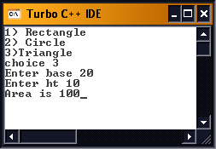
WAF to print the square and cube of a number
// WAF to print the square and cube of a number
#include<iostream.h>
#include<conio.h>
#include<stdio.h>

void sqr(int);
void cub(int);
void main()
{
clrscr();
int num;
cout<<"Enter number ";
cin>>num;
sqr(num);
cub(num);
getch();
}

void sqr(int num)
{
cout<<endl<<"sqr is "<<num*num;
}

void cub(int num)
{
cout<<endl<<"cube is "<<num*num*num;
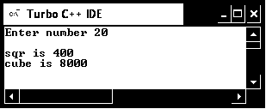
}
WAF to print Fibonacci series
// WAF to print Fibonacci series
#include<iostream.h>
#include<conio.h>
#include<stdio.h>

void fib(int);
void main()
{
clrscr();
int num;
cout<<"Enter last number ";
cin>>num;
fib(num);
getch();
}

void fib(int num)
{
cout<<"The series is "<<endl;
for(int i=-1,j=1,sum;i<num;)
{
sum=i+j;
i=j;
j=sum;
cout<<sum<<'\t';
}
}
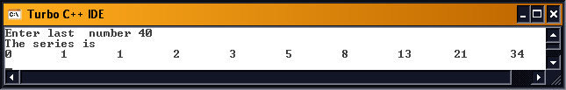
WAF to check if a number is a vowel or a consonant

// WAF to check if a number is a vowel or a consonant
#include<iostream.h>
#include<conio.h>
#include<stdio.h>

void vow(char);
void main()
{
clrscr();
char al;
cout<<"Enter alphabet ";
cin>>al;
vow(al);
getch();
}

void vow(char al)
{
if(al=='a' || al=='e' || al=='i' || al=='o' || al=='u')
cout<<endl<<"It is a vowel";
else if(al=='A' || al=='E' || al=='I' || al=='O' || al=='U')
cout<<endl<<"It is a vowel";
else
cout<<endl<<"It is a consonant";
}
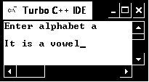
WAF to calculate simple interest
// WAF to calculate simple interest
#include<iostream.h>
#include<conio.h>
#include<stdio.h>

float simint(float,float,float);
void main()
{
clrscr();
float pr,rate,time,si;
cout<<"Enter principle ";
cin>>pr;
cout<<endl<<"Enter Rate of Interest ";
cin>>rate;
cout<<endl<<"Enter Time ";
cin>>time;
si=simint(pr,rate,time);
cout<<endl<<"The simple interest is "<<si;
getch();
}

float simint(float a,float b,float c)
{
float si;
si=(a*b*c)/100;
return(si);
}
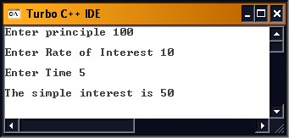
WAF to run arithmetic operations
// WAF to run arithmetic operations
#include<iostream.h>
#include<conio.h>
#include<stdio.h>

void operate(float,float,char);
void main()
{
clrscr();
float op1,op2;
char op;
cout<<"Enter operand 1 ";
cin>>op1;
cout<<endl<<"Enter operand 2 ";
cin>>op2;
cout<<endl<<"Enter operator ";
cin>>op;
operate(op1,op2,op);
getch();
}
void operate(float op1,float op2,char op)
{
float res;
if(op=='+')
{
res=op1+op2;
cout<<"The result is "<<res;
}
if(op=='-')
{
res=op1-op2;
cout<<"The result is "<<res;
}
if(op=='*')
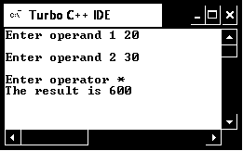
{
res=op1*op2;
cout<<"The result is "<<res;
}
if(op=='/')
{
res=op1+op2;
cout<<"The result is "<<res;
}
}
10.1) WAF to swap a number
// WAF to swap a number
#include<iostream.h>
#include<conio.h>
#include<stdio.h>

int swap(int&,int&);
void main()
{
clrscr();
int num1,num2;
cout<<"Enter number 1 ";
cin>>num1;
cout<<endl<<"Enter number 2 ";
cin>>num2;
cout<<"number 1 is "<<num1;
cout<<endl<<"number 2 is "<<num2;
swap(num1,num2);
cout<<endl<<"number 1 after swapping is "<<num1;
cout<<endl<<"number 2 after swapping is "<<num2;
getch();
}

int swap(int &num1,int &num2)
{
num1=num1+num2;
num2=num1-num2;
num1=num1-num2;

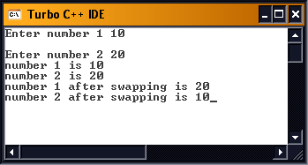
}
10.2) WAF to swap a number
// WAF to swap a number
#include<iostream.h>
#include<conio.h>
#include<stdio.h>

int swap(int,int);
void main()
{
clrscr();
int num1,num2;
cout<<"Enter number 1 ";
cin>>num1;
cout<<endl<<"Enter number 2 ";
cin>>num2;
cout<<"number 1 is "<<num1;
cout<<endl<<"number 2 is "<<num2;
swap(num1,num2);
cout<<endl<<endl<<"number 1 in calling function is "<<num1;
cout<<endl<<endl<<"number 2 in calling function is "<<num2;
getch();

}

int swap(int num1,int num2)
{
num1=num1+num2;
num2=num1-num2;
num1=num1-num2;

cout<<endl<<"Swapped value in called function of number 1 "<<num1;
cout<<endl<<"Swapped value in called function of number 2 "<<num2;

}

